March Newsletter 2020

Dates for the Diary:
“World Book Day” Thursday 5th March – The children are invited to dress up as a character from their favourite book on Thursday 5th March to have some fun with us on “World Book Day”.

St Patrick’s Day 17th March – All children to dress up in green clothes!

‘Mother’s Day” celebrated on 20th March - We are cordially inviting all our lovely mother for Mother’s Day Tea Party on Friday 20th March between 3PM-5PM. All children and Mummy’s/Grand mum’s/Nanny’s/Auntie’s are welcome to join us regardless of whether they attend this session or not! Please let management or a member of staff know as soon as possible so we can organise the numbers!

Dear Parents and Families,
It has been an amazing February! We hope you enjoyed as much as we did enjoy all our events and activities. We also must thank you all for your support to Koala hospital in Port Macquarie NSW, by donating some money in our donation boxes: We can say happily that we collected £101.44 which it is 200 AUD. Thank you!
Our focus was the five senses, Valentine’s Day and Pets. Children were given the opportunity to explore various textures and feel them, our vocabulary expanded to learn some new words wrinkly, prickly, fuzzy, gritty rubbery, bumpy, smooth, hard and soft etc. The children tasted different foods and talked about which foods they liked best.

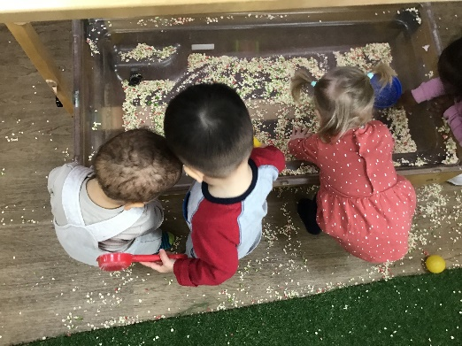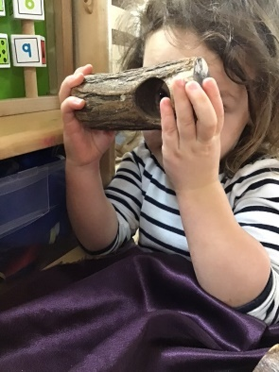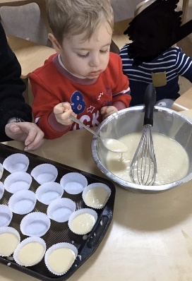

We celebrated Valentine’s day by exploring and engaging in many lovely activities we all talked about the joy of having our loved ones, families and friends in each of their lives. The children made cards, origami flowers for their parents and loved ones.
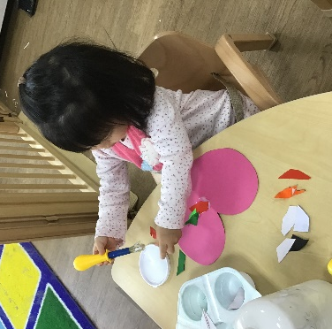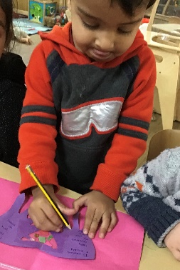
Also, we created our “Vets” corner where all Preschool enjoyed by doing roleplay and learning how to use all the instruments to heal our animals. We talked about our Pets and created the Family tree for under 2’s.

This March there are lots of fun and exciting events happening so have a look below. Our themes will be “Mother’s Day”, “St Patrick’s Day”, Changing time. We will be sharing stories, talking about our favourite books and characters and encouraging the children to write or draw a picture about them.
Under 2’s : This month in the under 2s room we will be focusing on our 5 senses. The activities we will be doing are making cupcakes, by helping our teachers putting and measuring the ingredients into the mixing bowl. We will also be playing with our musical instruments (making lots of noise) as well as singing “I love you” songs.
Moreover, for world book day we will be bringing and sharing with our friends, our own favourite book from home.
Furthermore, in the garden (if the weather permits) we will be learning new words linking to the five senses.

In 2-3’s: we will be celebrating St Patrick's Day, Mother's Day, World Book Day and learning about wild animals. We will talk about what activities we do together with our mothers, we will make special cards and picture frames as presents. We will talk about the colours of the rainbow and concentrate on the colour green during our celebrations for St Patrick's day.
For World Book Day we will dress up as our favourite book characters. We will also ask children to bring in their favourite books during the month so we can read them together. Children will learn about different wild animals, where they live and what they eat.
We will continue to concentrate on counting and recognising numbers from 1-5, as well as our phonics and the 5 Golden Rules.

Preschool:
The outside world shapes children's development through experiences that they have, which include using their five senses—hearing, sight, smell, taste, and touch. Drawing a child's attention to the five senses and discussing them increases understanding of and communication about the world around us. Preschool will be exploring the five senses during the month of March.
In addition to the same, preschool will also be celebrating the World Book Day, St.Patrick’s Day and Mother’s Day with various activities to make the important days more special.

Challenge for Pre-School Children:
TALKING ABOUT FEELINGS Learning new words and experience different feelings. Being able to express themselves. “How do feel today? How was your day at nursery? How did this movie make you feel?”
SHARING IS CARING Taking care of others means sharing too! We learn how to take turns and enjoy our resources being fair.
TIDYING UP After playing, put everything back as it was. “Let’s pick up 20 things from the floor…”

I would like Parents to encourage children to follow our Challenge of the month as it narrows gap of communication with the Teachers and enables great relationship!

Don’t forget our £500/£250 referral reward. Just ask the other person making the enquiry or booking to mention your name.
Please send in your Reviews, a small gesture of appreciation will encourage us to achieve our desired goals!

GENTLE REMINDER!
Front Door: Please can we remind you all that you must not let other parents/carers in the door when entering/leaving the building. For your children’s safety it is vital that we know exactly who is always in the building. Thank you in advance for your co-operation!
Drop off times: Please create a smooth transition during drop offs, allow enough time to handover your child to respective teachers! Please do not hang around if your child is upset as you will distress your child even more. Due to high number of sickness, we would appreciate if you only allow teachers with blue gloves to serve breakfast to your children. I would appreciate if parents didn’t serve breakfast to your children! If you think if your child didn’t have a great night, please inform us at your earliest convenience, this give us a good insight on your child’s needs and requirements!
Pick up times: Just a polite reminder to all our parents that the sessions end at 1pm and 7 pm. Please ensure you arrive at 12.50 and 6.50 at the latest to receive a handover (verbal feedback) about your child’s day. We are having quite a lot of parents collect late meaning the handovers run over time. We have daily reports being sent as well and if you require to have verbal feedback as please allow not more than 5 minutes as this take staff away from ratios and other children are being neglected. Thank you in advance.
Appropriate clothing: Now that the weather is getting a little colder please can we remind you all to bring in appropriate clothing for the children to be wearing in the garden. We are still having a lot of children who are not bringing in a coat and unfortunately, we do not have enough spares for them all to wear. Please kindly label the clothing as much as possible especially in the baby-room!
*Label your children’s clothes We would really appreciate if you could label the name of your child in all their clothes as it would be very helpful for us when changing them after messy play, getting them ready for garden time and putting their shoes on when home time. Even though we encourage them to do it themselves, it would be great for them if they also are able to recognise their names on it.
Sickness: If your child shows any signs of being unwell, please keep them away from nursery. This is to stop it from spreading to other children and staff.
Prescription Medicine: If your child is on prescription medication, please ensure medicine is clearly labelled and you have filled the form on Genie before leaving the premises. Childs medication will only be accepted after seeing the correctly labelled medicine or a medical note.

The Orchard Day Nursery has an open-door policy, if you have any questions please speak to management, we are always happy to help. Thank you for your continuous Support!
Erum and the Nursery Team

