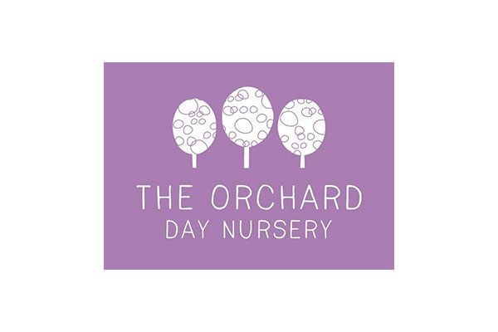
Newsletter September/ October 2019

Welcome back! To all our returning children and parents, and a warm welcome to all our new families. It’s time again for some news, reminders and dates for your diary.
Dates For you Diary:
27th September 2019-Macmillian Coffee Morning 9:30-11:30- We would like to invite all parents to join us for Coffee Morning and celebrate this good cause, requesting parents to bake cakes and support us to sale cakes. It will be good opportunity for you to socialise with other parents.
18th October 2019- As we are covering Harvest Topic, we would like to request Parents to send in non-perishable food items to be donated to our local food bank.
25th October 2019-Diwali party 1:30-4:30- All parents to come and join in our festivities and celebrate Diwali
31st October 2019 1:30-4:30-Halloween Party-Welcoming parents to join in our celebrations with their children. All children to dress up.

In Preschool room -we have been looking at food from around the world, cooking daily and gaining new experiences to something personal. We have been looking at 2D shapes in Maths area, finding new shapes in the environment.
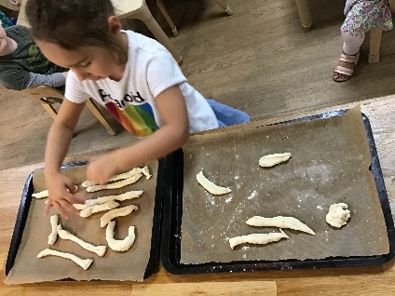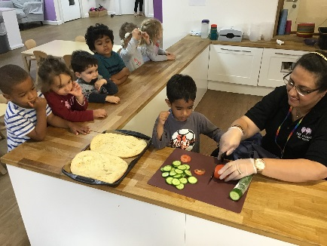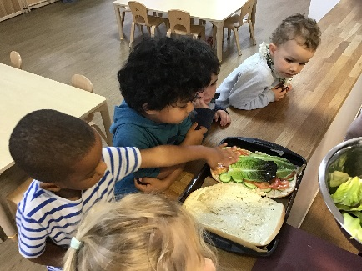
Next week we will be focussing on our listening skills, particularly distinguishing between different sounds. Please encourage your child to talk about what they can hear at home and when you are out and about at the park/supermarket etc. We will continue to talk about the sounds they have heard in and around Nursery.
In the coming month we will be learning about Topics including Autumn, harvest, naming main body parts Identifying plants in our Wild Garden - trees Autumn Walk - observing changes, Self Portraits Leaf printing House pictures. We will be looking at numbers in the environment and counting objects with Numbers. IN ICT we will be learning, My World Simple City (Park) To use and stay on programs as modelled and directed by teacher/adult. (e-Safety) To move objects on a screen with a mouse and touchscreen technology (iPad). (Data handling and Multimedia) To be kind to our friends when using the computer (e-Safety)

In Toddler room we have been exploring and mixing autumn colours, we focussed on Keeping Healthy - learning the importance of good hygiene - hand washing. In the coming month -We will be Observing changes to materials. looking at different woodland animals-learning their names and reading more stories about them. We will also be focusing on Golden Rules, Healthy Snack Staying safe indoors/outdoors What do I look like? Who are my family?
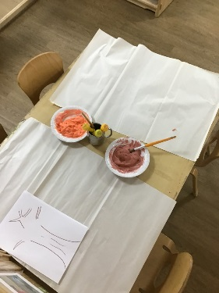
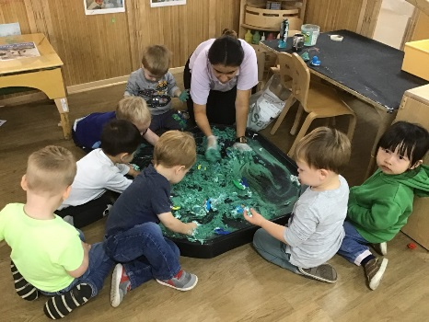

In the baby room we have been exploring messy play with sticking and gluing, mixing colours and singing lots of nursery rhymes. All the new children have settled well and enjoy the extra-curricular activities.
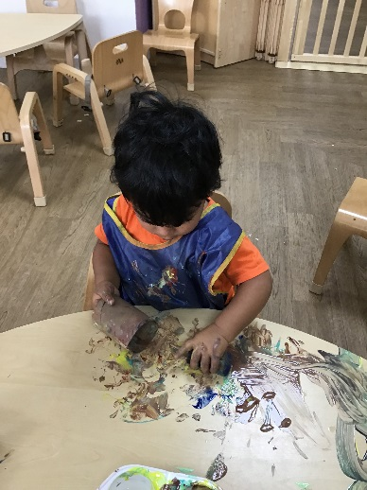
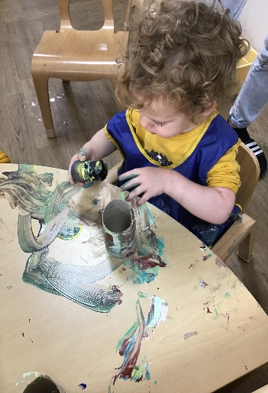
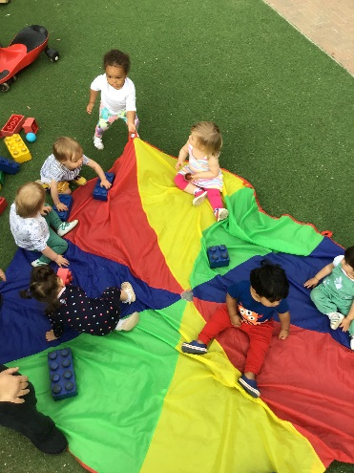

Important Reminders!
The kitchen area is for Staff use only, May I kindly request parents to not direct your children towards the kitchen due to health and safety. We can help and assist you with anything you require!
As a key part of creating a welcoming environment we would like to provide this opportunity for our new mothers to kindly use our bedroom/sleep room for breastfeeding your child in peace and comfort.
New Menu for winter has been updated. Please check our website to download the menu.

Your child’s attendance Please make sure that your child attends Nursery regularly. Nursery is a great time to start building a habit of good attendance. Studies show that good attendance in Nursery can set a good pattern for attending school later. Please always contact the Nursery if your child is absent for any reason, particularly if they are unwell, as we may need to let other parents know if there are infectious diseases or ailments.
We also plan special events and it is helpful to know if children are going to be absent or will be in late.
Sign in / sign out Please remember to sign your child in and out in the book in the main corridor.
Keeping us informed... Please let us know if there are any changes in your home or family that may affect your child, e.g. moving to a new house, new partner, a death in the family, or simply a change in your usual routine. We can then support your child through any changes. Thank you.
Contact Numbers We may need to contact you urgently if your child becomes ill at Nursery. Please give us up to-date contact telephone numbers, including an extension number for your school or department, if you are a student. Ensure that your mobile is always switched on (even if on “silent”), whenever possible. We will be requiring you update us with your emergency contact details and passwords.
Safety and security Please do not admit other people into the Nursery or allow them to come inside when the door has been opened for you, even if it is a parent you know. If you are leaving and a person is at the door, please inform a member of staff before opening the door. Only Nursery staff must admit parents or visitors. Be very aware of any other parents and children in the corridor as you leave; do not inadvertently let another child out of the door ahead of their parent.
Children illness Please keep your child away from Nursery if they have a raised temperature, a severe cough or lots of sneezing. Children can come to Nursery with a mild cold, if they are well enough to play. If your child has diarrhoea or vomiting, please keep them away from Nursery until they have been clear for 48 hours
As the weather begins to get a bit colder please be aware that the children in Nursery tend to spend quite a bit of time outside, if it looks like it could be chilly/wet please send in a coat and welly boots which are clearly named.

We value and appreciate our strong relationships with parents and guardians. Thank you all for your continuous support. We have an open-door policy and would welcome any comments and suggestions

Kind Regards
Erum Syed

