Preschool Room  Topic  In July we will be focussing on Sports and charity picnic, with Wimbledon Open round the corner, women’s football world cup and cricket world cup we will be discussing importance of sports based on the EYFS (Physical Development) Practitioners will be organising different physical activities and indulge the children taking part and choosing activities based on their abilities. They will be taugh names of Sports players,teams and their country of origin. Parent’s and carer’s can build on this theme by talking to your child about the different kind of sports you like, teams you sport and so on.  Thank you for your co-operation. |  | Dates for your Diary  The under 2’s children will be having their sports day on Monday 24th June 2019.  Helen Warrick (the photographer from the previous year) will be taking photographs on 26th June of the preschool children that will be graduating. Please see the posters and do not hesitate to ask Sonia/Erum if you have any queries.  Graduation Day- Friday 19th July. The preschool children will be putting on a show courtesy of Theatrebugs (who comes in on a Thursday) for you all! |  |  | Sarcoma charity picnic has been organised by Hollie on Friday 26th july 2019 she would be incharge of this upcoming event .Please feel free to discuss this event with her. We would like to invite all our families to join us for a day of -themed activities, food, bake sale, raffles and fun.  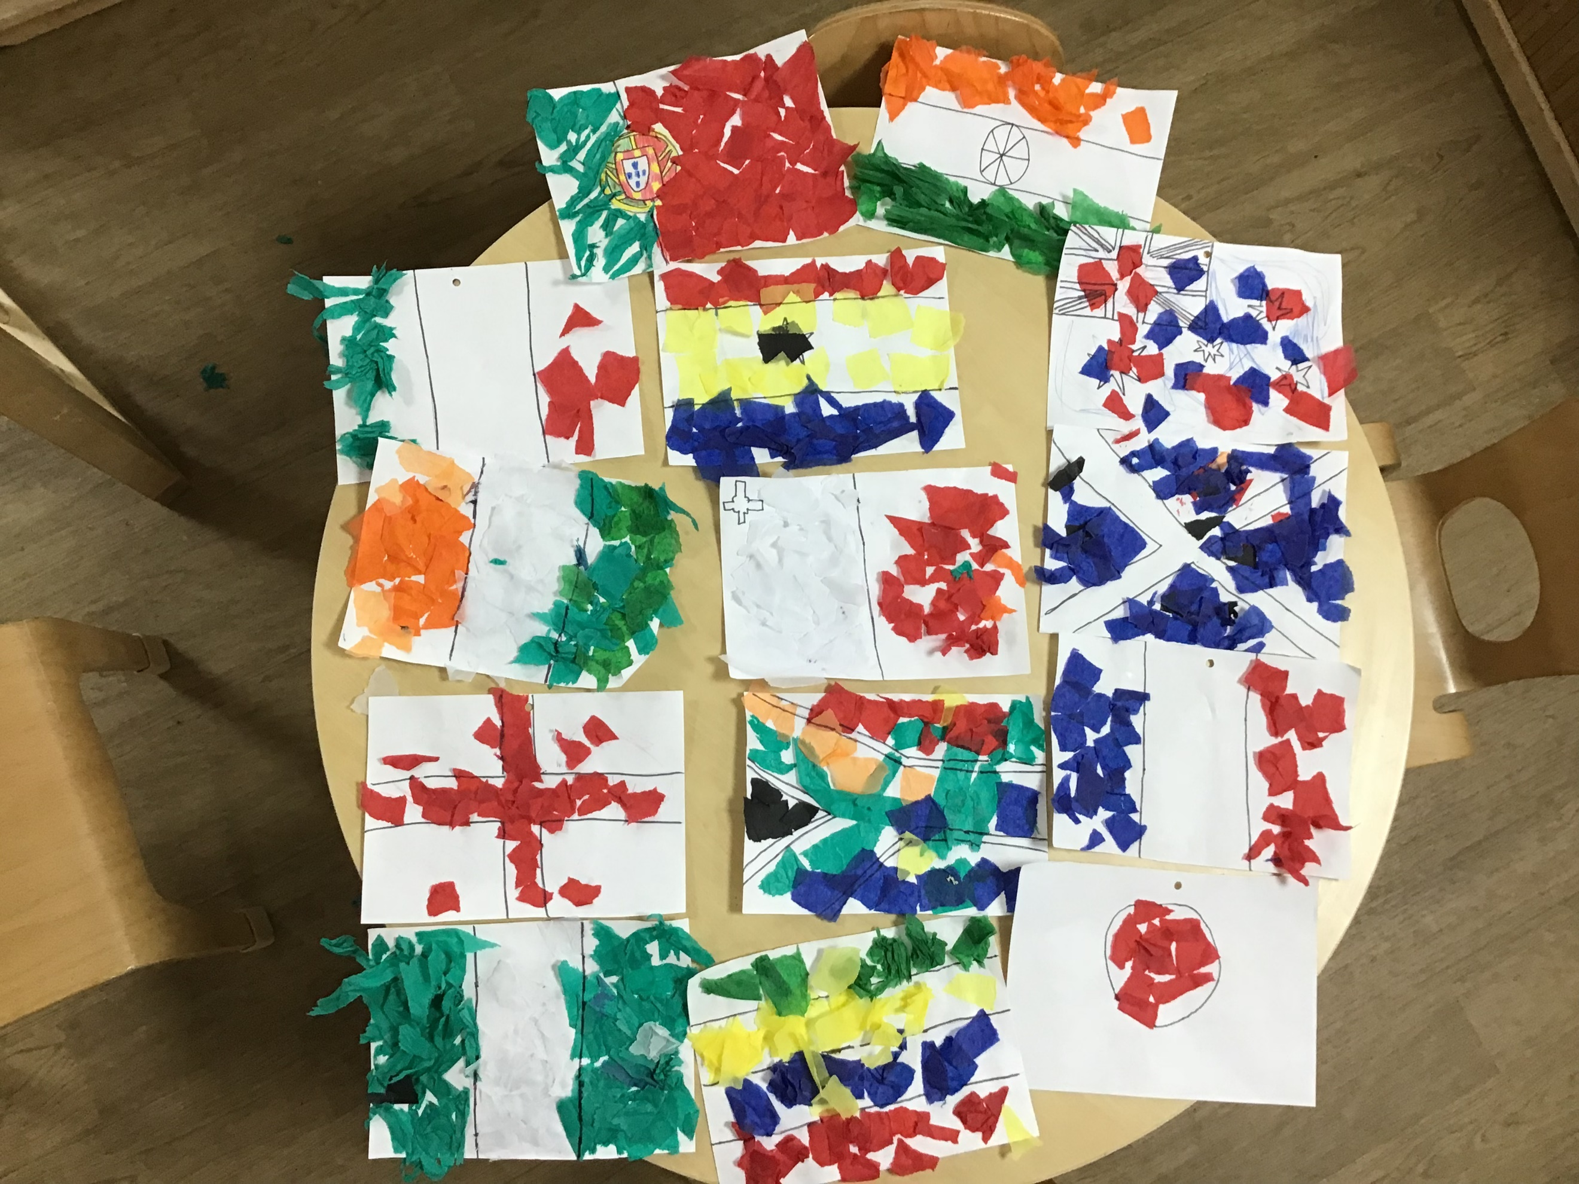  Different flags created by Pre School children for All About Me display board!
Staff News!
A sad goodbye…We would like you all to join with us as we bid a farewell to Paige (from our 2-3’s area) who will be leaving us on 28th June.
We wish her all the best in her future endeavors as she further continues to pursue her education!
We would like to welcome Elizabeth, who has recently joined our Team and will be working in 2-3’s room and replacing Paige!

2-3’s Room  We will be doing lots of science experiments coming week including a floating and sinking activity with items that they have found around the nursery. We will also be indulging in messy play!  2-3’s will also be painting small plant pots for our new seeds we are planting for our nursery garden.  We would be going out for nature walk as a part of current topic to discover natural materials for our sticking activity.  Exploring natural resources for messy play!  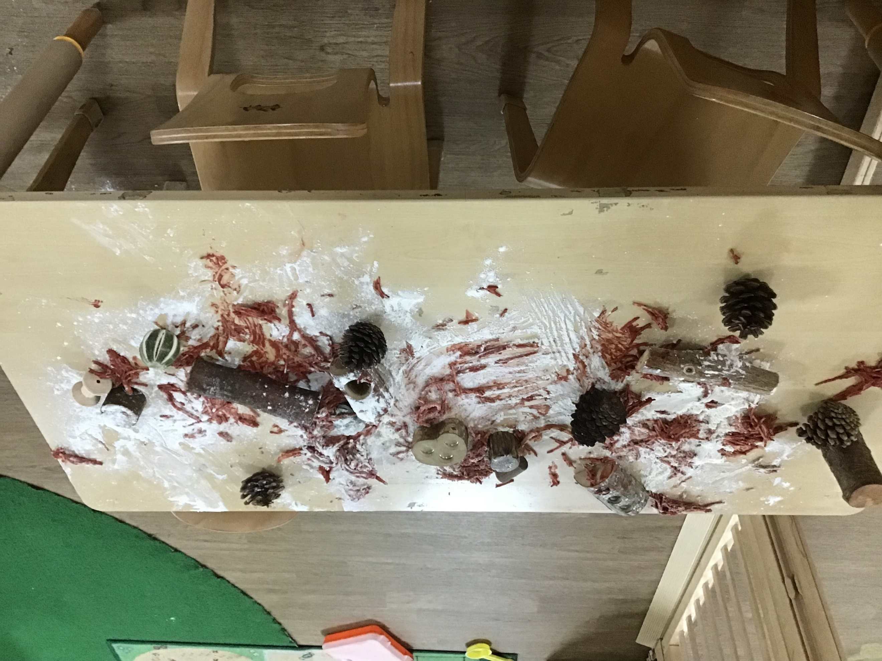 |  | Key workers system  All the children are provided with a dedicated staff member who fully understands the learning, development and care needs of your child, this gives you the confidence to leave your child at the nursery knowing they will be cared for in a way that is tailored to the information that you provide. . They will also be the main practitioner carrying out the child's intimate care needs, such as putting to sleep, nappy changing and physical closeness. Any information shared with the parents is also done mainly through the key person.  To ensure consistent continuity of care for all children, each key person is paired with a 'buddy' who will take on the role of the key person during periods of absence such as holidays. It is part of the key person's role to ensure that their 'buddy' and other staff within the environment are aware of their key children's needs and have a strong relationship with the parents to enable clear communication.  Over the next few weeks there will be a change for some of the key workers/buddies. You will be notified of your child’s new key worker before the change comes into effect.  Enjoy our Fortnightly newsletter! |  |  | Under 2’s  We will be using our senses through touching and feeling activities. We will be encouraging the children to explore and discover new toys and take part in new experiences, such as heuristic play sessions, music sessions and sensory play. We will be asking for information from home, such as what your child likes to do at home, who is in their family and what new things they have been doing. This will help us to bring an aspect of home into nursery and have an insight into the things they do at home. We will continue to do lots of singing nursery rhymes which really help promote early communication and language in young children. If you would like to do this at home with your child and are unsure of some of the rhymes we sing at nursery, please speak to your child’s key person and ask for a nursery rhyme sheet.  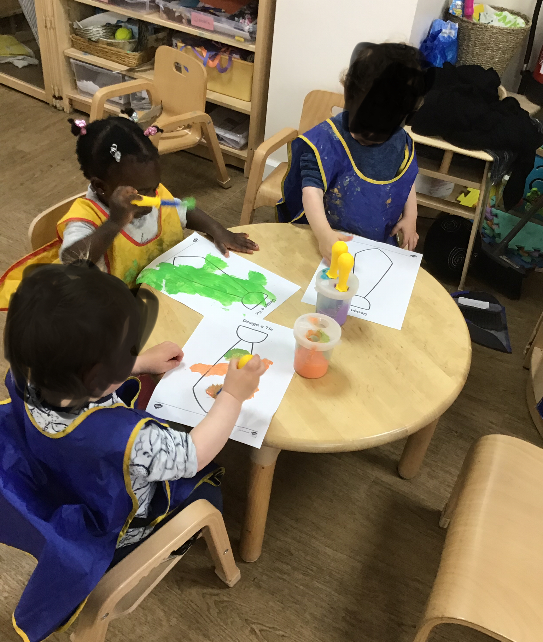  Babies had fun creating Father’s Day ties for dad’s!
 |  | Happy July Month

